**CSE 331 1ST HOMEWORK REPORT**

Şiyar Tarık Özcaner

200104004021

04/11/22

Q1)

Execution time: Instruction count * CPI * cycle time (let’s call cycle time x)

R-type: 50*2*x = 100x

I-type: 30*4*x = 120x

J-type: 20*3*x = 60x

Total = 280x

Since the I-type has the most execution time it is the obvious target for any improvement.

Question says the improvement will be %50 so:

Compared to task/performance = t execution time

It’ll take task/1.5 * performance = 2t/3 execution time

Int the end:

120x * 2/3 = 80x execution time

Modified total 100x+ 80x+60x = 240x

Finally, the improvement rate = 280-240/240 = %16,6

Q2) the terminal is quite self-explanatory:

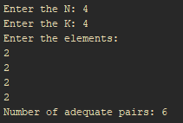

Terminal first asks for n value, and it is entered by a enter after the integer which is how all the input is entered,

Then it asks for the K value (If it inputs are invalid it asks for inputs again)

And lastly elements of the array.